Image-Magic and Delocation Problem

ZEISS Hackathon 2019 – Mission Briefing

SMT-EMIM / Dr. Ringo Wenzel

# Background and Situation

One option to construct free form surfaces is to combine them from various surface elements (SE). While doing so, it is crucial to ensure the correct placement of every single SE. This calls for a strict process control to avoid a displacement or rotation of the elements during the fixation process. In the process that the task, described here is based on, this is done by analysing pictures that were taken before and after the mending of a SE to the support structure.

# Main Task and suggested sub steps

The basic task is to decide, whether a not acceptable displacement of the SE occurred between two given pairs of pictures. In every pair, the leftmost and rightmost part of the SE is shown. By identifying the position in the picture, it is possible to quantify differences in between two pairs of pictures. To allow for a correct determination of physical Units, reference structures of known Positions are also shown in every image.

The basic task is therefore:

* Provide a method that checks a new set of pictures and decides whether this surface element is still „in Spec“, after the mending process.
* This includes the definition of a good specification.

Additionally functions are desired but optional:

* Instead of using a fixed specification, a quality number should be assigned to every SE. This number starts at 0 for all displacements larger than a given threshold d1 (which is equivalent to “out of spec”) and increases linear to 1 for all SE with a smaller displacement than a second threshold d2 (d1 > d2).
* The routine should give an error message, if the distribution of the last x samples is with a probability of more than y% different to the expected base distribution (where x and y is configurable).
* In case of surface defects on the upper side, a SE is automatically out of spec.

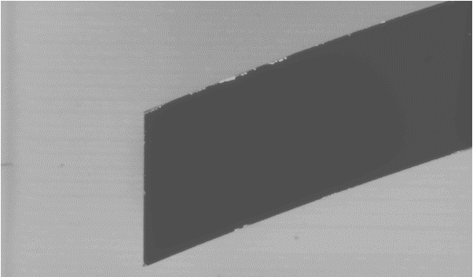

To achieve the described goal, we suggest the following sub steps:

* A method is needed, to identify the surface elements position in a picture in a fast and precise manner. This is not a trivial task, since the background is sometimes structured:

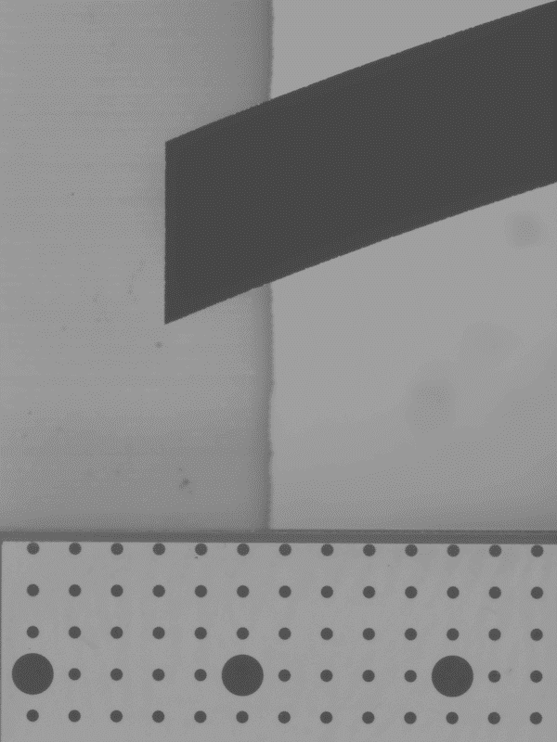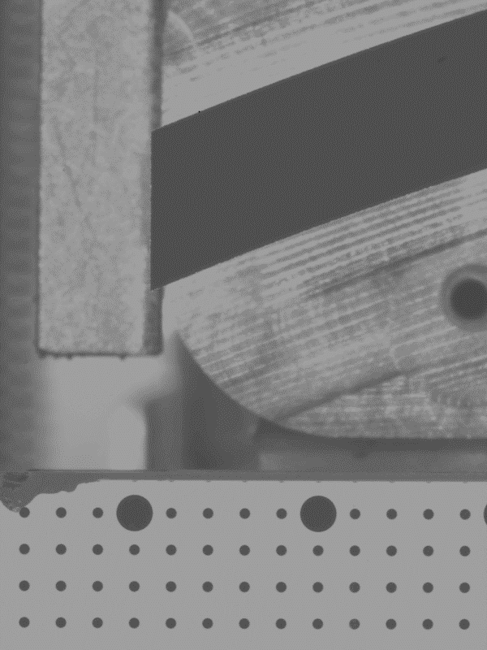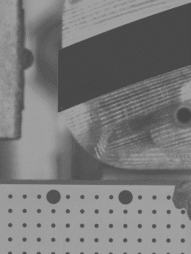

* The displacement (and possibly rotation) due to the production process has to be calculated based of the position results for every picture
* Then it is interesting to calculate and visualize the associated distribution(s) for a selected sub-sample.
* After visualizing the yield as function of displacement (and rotation) tolerance, a specification based on a required yield can be decided. In case of the usage of a quality number, the thresholds d1 and d2 should be determined instead.

Please note: The described strategy is a straight forward approach, there are others that might be more elegant.

# Constraints for tolerance definition

The displacement tolerance should be determined such, that a first pass yield of 80% can be achieved. If a quality number rating is used, the best 50% shall achieve a rating of “1”.

# Explanation of data

As input for the described task, in total 2081 data sets are provided.

* Each data set consists of 4 single grey scale pictures with 600px x 800px.
* Picture meta information is coded to the file name as follows:

nnnnnn_dddddddd-tttttt_p.tif

* nnnnnn … 6-digit ID-number of the processes surface element.
* dddddddd-tttttt … DateTime of the picture recording.   
  (e.g. 20160815-201325 means 15.08.2016 20:13:25)
* p … position coding (either “L”eft oder “R”ight)
* The 4 images in one set (showing the same SE-ID) picture the following
  + Left section before processing (e.g. “342181_20160815-200938_L.tif”)
  + Right section before processing (e.g. “342181_20160815-200938_R.tif”)
  + Left section after processing (e.g. “342181_20160815-201325_L.tif”)
  + Right section after processing (e.g. “342181_20160815-201325_L.tif”)
* In every picture, the dark, lightly curved structure, is the SE.
* The absolute scale is defined by small dots that are visible in the base plate. The distance between each two dots is 1mm. Every fifth dot is significantly larger.

